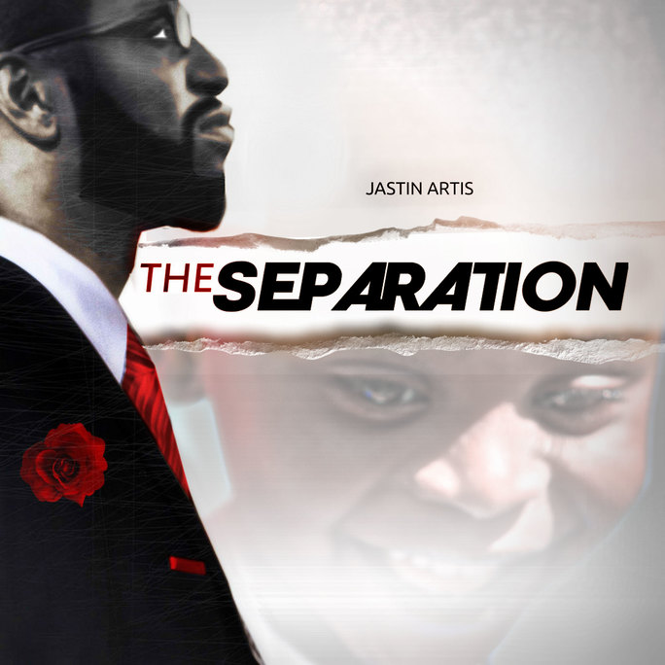

Jastin Artis kick-starts hip-hop renaissance
with new album ‘The Separation’

WASHINGTON, D.C. – According to the organization, National Kids Count approximately 35 percent of children under the age of 18 live in single-parent homes in the United States. As many as 25 percent of children live with their mothers only and that’s more than 18 million children who don’t live with a father figure. By comparison, father-only households make up only 8 percent.

Jastin Artis is on a mission to change those stats. As a father currently in the midst of a custody battle with his ex-wife, he knows all the struggles that single fathers go through to be able to have valuable, quality time with their children. And while he shakes his head in shame at those fathers who walk away from their responsibilities as parents and leave mothers to raise children on their own, he feels a righteous anger for all those fathers who want to have a role in their children’s lives and aren’t allowed to because of the nature of the “system.”

His new album, “The Separation,” is a project dedicated to changing this dynamic in America. Not only is it a project that chronicles his recent experiences, but it’s also a deeply inspirational album filled with music and lyrics that make listeners perk up and pay attention.

“This is a significant album for me,” he said. “It was born from a broken marriage and the pain of that, and the love and joys of parenthood. It tackles things like fighting parent alienation due to what happened in my marriage, and the injustice of trying to be a dad and not being able to. There are all types of things people are fighting for and trying to bring awareness to, and I decided to do my fighting through my music. It’s really significant to me to get awareness for this. When you see this album you see a young black male trying to be positive about the greatest relationship you can have – a marriage – and it didn’t go right. But I’m pushing through and found new love as I try to be with my son. And along the way I think people will find more to what ‘The Separation’ means to them and how it applies to their own lives.”

Artis is a new artist whose brand of music fuses Gospel, acoustic and electric guitars, and spoken-word to give a new wave in typical hip-hop music. In a lot of ways he’s the bridge between genres that music fans didn’t even know they were looking for. But once you hear his unique sound and style it’s impossible to turn away. In fact, it’s more likely you’ll be hitting repeat as you get sucked into his songs by his musicality and pulled deeper by his insightful lyrics.

Take his debut single, for instance. “Never Will” is a song that has layers of sound with a catchy beat that drives and moves the listener forward. Almost immediately you get stuck in the groove and can’t let go – not that you want to – and somewhere along the way you realize that his delivery is catchy. That’s an over-used term, but in Artis’ case it’s the perfect word to describe what’s going on with his music. When you hear the way he delivers his lyrics across his high-quality music, it catches your attention. And once he has your attention, he hits you with deep lyrics and high-quality instrumentation and first-class production for a sound that is truly original. It’s hip-hop renaissance.

“As an artist I’m a different brand of hip-hop,” he said. “People need to know I exist. Music is the thing that saved my life. If I didn’t have music, I don’t know how I’d be able to live every day. I want to give that to other people. Any song I do I give people a real truth that maybe they’ve never heard before, or at least not in a way that I’m putting it. Then I go deep. I don’t make surface music. I want to elevate people and help them grow and figure some things out. Come to me and we can figure out that pain and our lives together.”

As Artis continues to produce music and release it to the world, he said he hopes to create a movement behind his cause. He’s even coined the phrase “The Separation Movement,” with the hopes that others will join the cause. More than anything he wants to shine a spotlight on the injustice of it all, and get more people engaged in affecting positive change in the world. “It’s more than music, it’s a movement.”

Jastin Artis will be performing LIVE on Jan. 13 at the Pure Lounge in Washington D.C. Tickets are available at www.aftonshows.com/jastinartis

Jastin Artis’ music is currently available across all digital distribution outlets. To listen to his music, or to follow him on social media, please visit:

Website: justapuppet.com/tsm
BLOG: amanelevated.blogspot.com
Facebook: facebook.com/separationmovement/
Twitter: twitter.com/jastinartis
Instagram: instagram.com/jastinartis
YouTube: Youtube.com/jartisproject
SoundCloud: http://soundcloud.com/jastin-artis
LinkedIn: Linkedin.com/in/jastinartis

© Starlight PR

